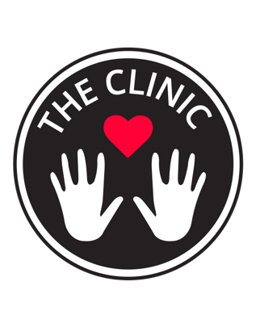
Theclinicperformance.com
Tara Rynders
720-469-7134
theclinicperformance@gmail.com

Nurses Supporting Nurses

Tara Rynders recently (May 2020) featured in Newsweek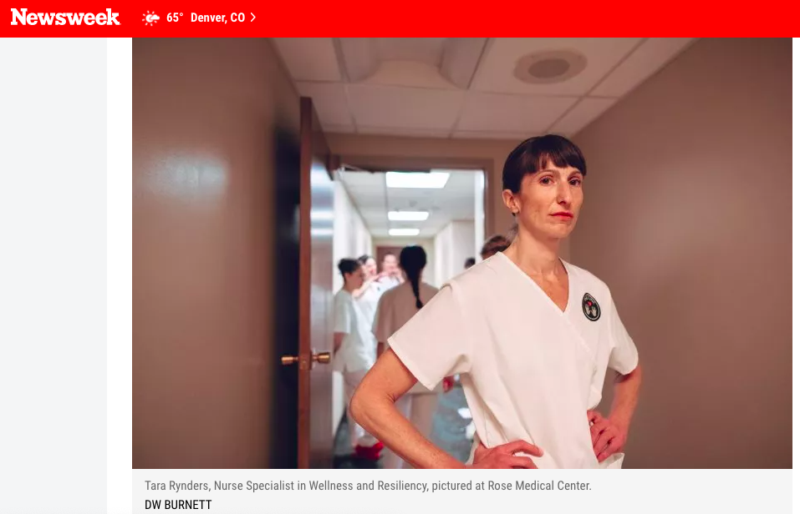

Tara Rynders recently( April 2020) featured interview in The Art Newspaper (London and NYC)
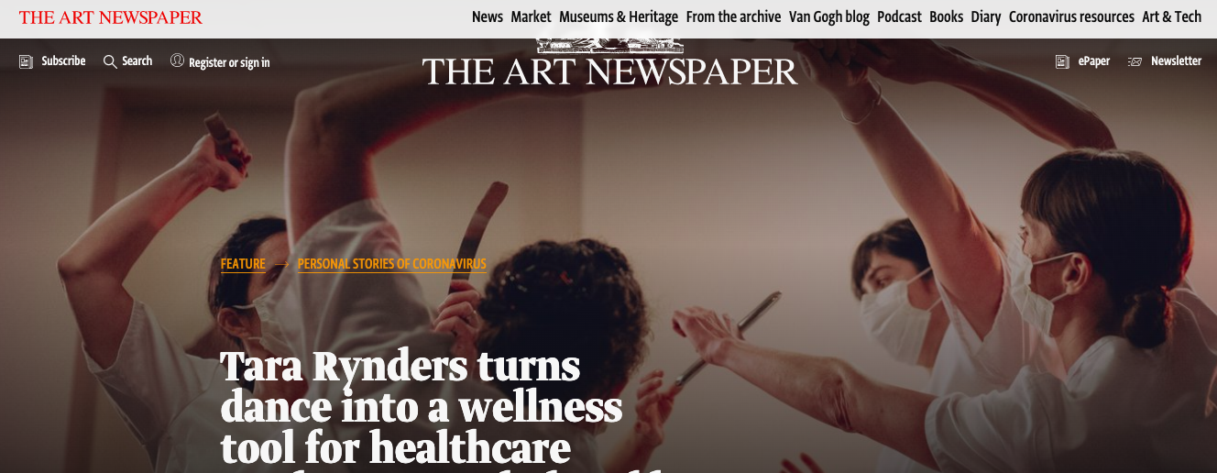

Tara Rynders recently (April 2020) featured interview from ABOG website (NYC)
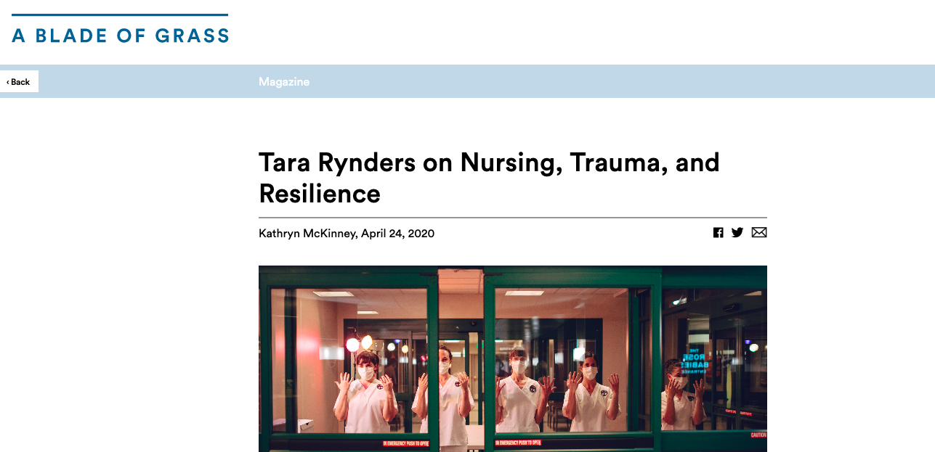
CPR interview for Resiliency Moments (June 2020)
CPR interview( October 2018) for promotion of First, Do No Harm
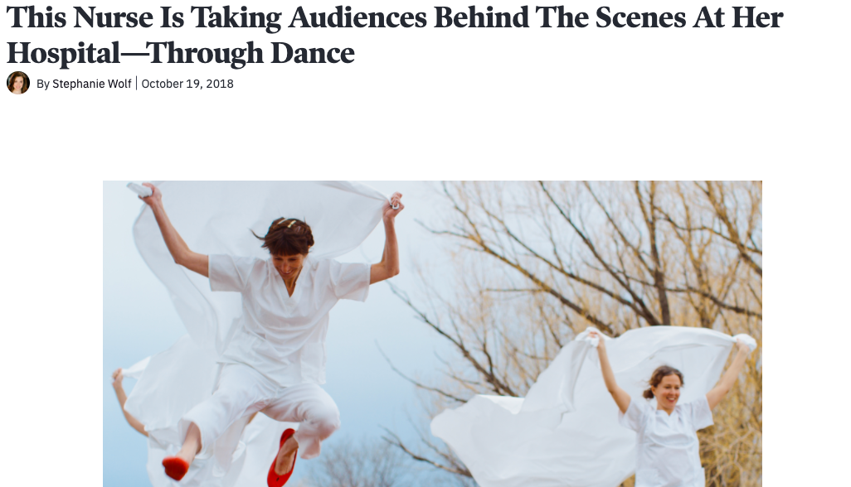
Important Video Links: All video work filmed and edited by Drummond West
COVID Stories
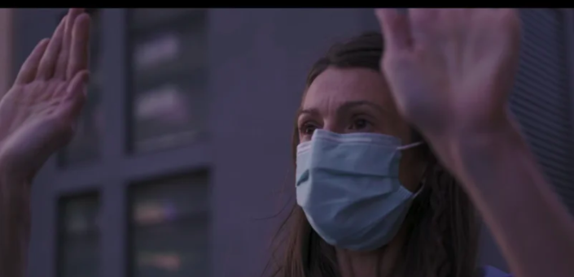
COVID Stories II
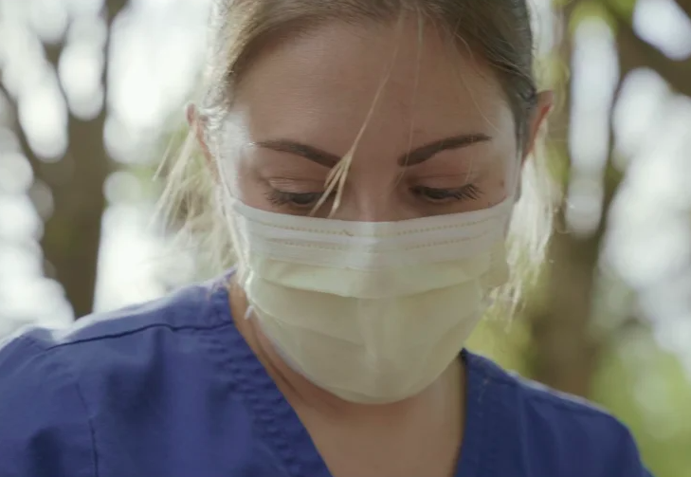
Workshop video for nurses
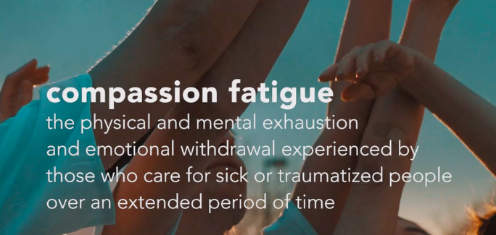

First, Do No Harm
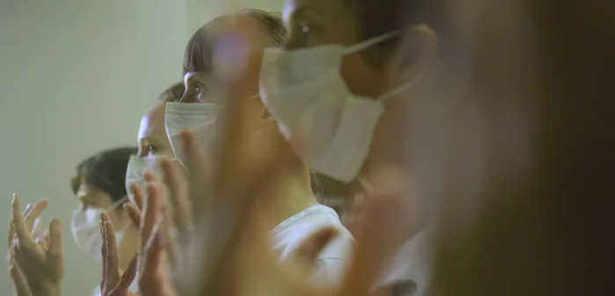

Resiliency Moments (upcoming)
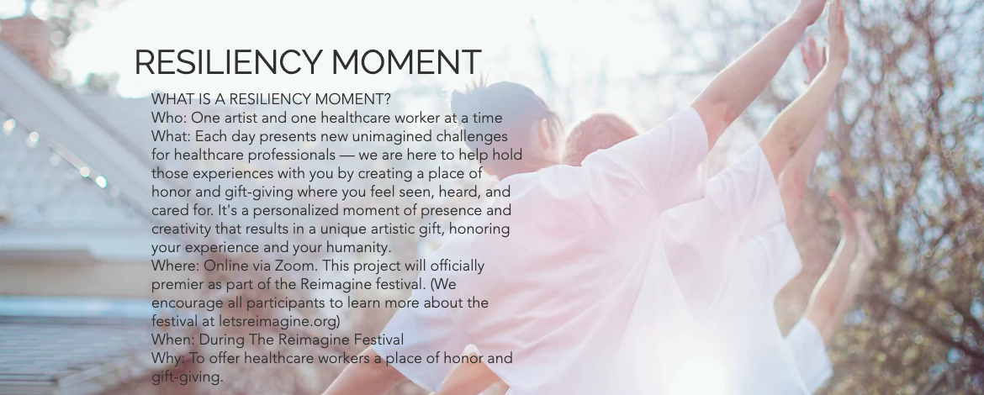

About Tara Rynders:
Tara Rynders has been a nurse for over 15 years and works at Rose Medical Center as a Nurse Specialist in Wellness and Resiliency. She is the artistic director and founder of The Clinic , a six week arts-based workshop series for nurses and First, Do No Harm, an immersive theater performance that takes place inside active hospitals and is open to the general public. First, Do No Harm first premiered at Rose Medical Center and was set to perform pre-COVID in a hospital in Brooklyn, NYC this June, along with workshops for nurses, for the Reimagine End of Life festival. Rynders has a Bachelors degree in Nursing, a Bachelors in Spanish, and a Masters in Fine Arts with specialization in Movement and Somatic Practices. She is also a Certified Grief Recovery Specialist.
Tara has combined her expertise in arts, mindfulness, dance, and movement with her nursing practice to create immersive experiences for colleagues in health care that support self-care and raise awareness about the detrimental effects of compassion fatigue, burnout, and secondary traumatic stress. In 2018 she produced the immersive theatrical experience, First, Do No Harm, in which the audience accompanies performers throughout the halls of Rose Medical Center. This one of kind immersive theatrical performance allowed the audience members to see and experience the weight that patient care and illness has on caregivers and their family members. Her innovative melding of art with nursing and science was recognized through the highest level of nursing recognition in Colorado when she was given the Nightingale Luminary Award last year. Tara is passionate about caring for caregivers in order to reduce burnout, secondary traumatic stress, and compassion fatigue. She has an amazing talent for combining the arts with science which has been recognized by numerous grant and scholarship awards. Notably she has been awarded grants to pursue her vision for nursing research and arts-based resiliency workshops through A Blade of Grass Fellowship, and multiple Grants through the Arts in Society, Reimagine Denver 2020, andColorado Creative Industries.

Research
Pre and Post workshops for nurses

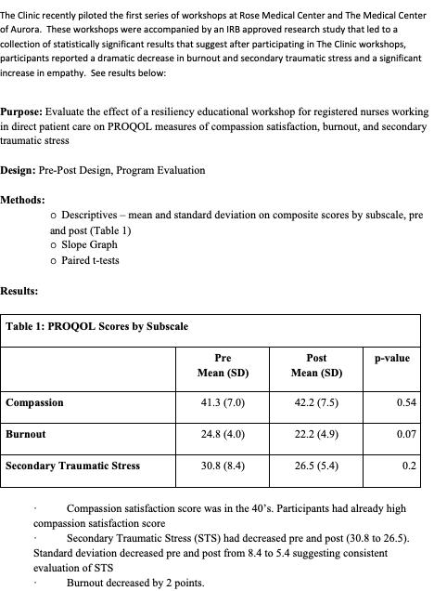

After spending many years caring for family members:
- At 26 years old her mother passed away to a rare form of cancer when she was 49
- Her brother, who suffered from mental illness, passed away alone in the hospital at age 30 as an incarcerated individual and no one called family to let them know he was dying, so he died alone.
- Her sister at age 26 went into a rare coma due to ADEM (acute disseminating encephalopathy) and has since been locked in, unable to speak or move, except small movements in her upper arms, Rynders spent every day with her living in her rehab room for over 3 months helping her awake from her coma, being her advocate, and her voice.
Rynders was a patient herself and almost died after her fallopian tube burst due to an ectopic pregnancy. During her experience as a patient alongside her experiences caring for her family, Rynders realized the huge and important role nurses have in caring for their patients. She remembers distinctly her nurse holding her hand when she passed out and was bleeding internally, her nurse whispered in her ear, “I am here with you and you are going to be ok,” she was so grateful for this moment because she was so scared and she couldn’t speak.
Rynders began researching patient outcomes, patient satisfaction and all the data brings us back to the importance of the nursing care at the bedside. This data also shows our nurses are tired, they are burned out and they have little to no support. More research data available upon request.
Rynders has taken all these experiences alongside her long-time experience as a nurse to create The Clinic, a workshops series for nurses to combat compassion fatigue, burnout, and secondary traumatic stress and First, Do No Harm, an immersive theater performance that takes place in the hospital setting open to the general public to raise awareness of compassion fatigue and nursing burnout.
To create First, Do No Harm, Rynders brought together a group of nurses, artists, dancers, musicians, and a script writer. From there, they researched and developed a script that explores issues of compassion fatigue and burn-out, from the nursing perspective. Her team rehearsed weekly at Rose Medical Center for six months to create this production. With the support of Rose Medical Center CEO Ryan Tobin, CNO Lynne Wagner, Security Officer James Butler, and Marketing Director Julie Hogan, her group brought audience members on a two hour journey for the performance, which also took place throughout Rose Medical Center.
The First, Do No Harm journey follows a woman who arrived at the hospital to find that her husband who is only 42 years old has been placed in critical care after a heart attack. The audience experiences this story from the perspective of nurses, the patient, the patient’s wife, and the perspective of Death - an actual character.
Woven throughout this story is a through line of compassion fatigue, burn-out, loss, grief, life and death. The performance ends in the chapel, with all performers listening to a monologue performed by Death, speaking to what happens after one’s life has ended.
Death admits she does not know what happens, and offers an alternative - “Maybe there is dancing?”.
This query prompts the nurses to enter for a dance finale, reminding us that our shared capacity to grieve, may also the capacity we have to feel joy.

Many healthcare workers attended the debut performance series, and shared important feedback, including one person who said that, “It spoke to the decades I have spent witnessing the grief of others, and captured the compassion fatigue we are all vulnerable to feeling.”
Overall the nurses in attendance said they felt both seen and heard, as they witnessed their stories being told and brought to life for an audience; nurses said they felt appreciated and respected for the incredible and difficult work they do daily. The general public audience also spoke to having an increased amount of respect for nurses by gleaning a deeper understanding of what it is that nurses are tasked with in their professions.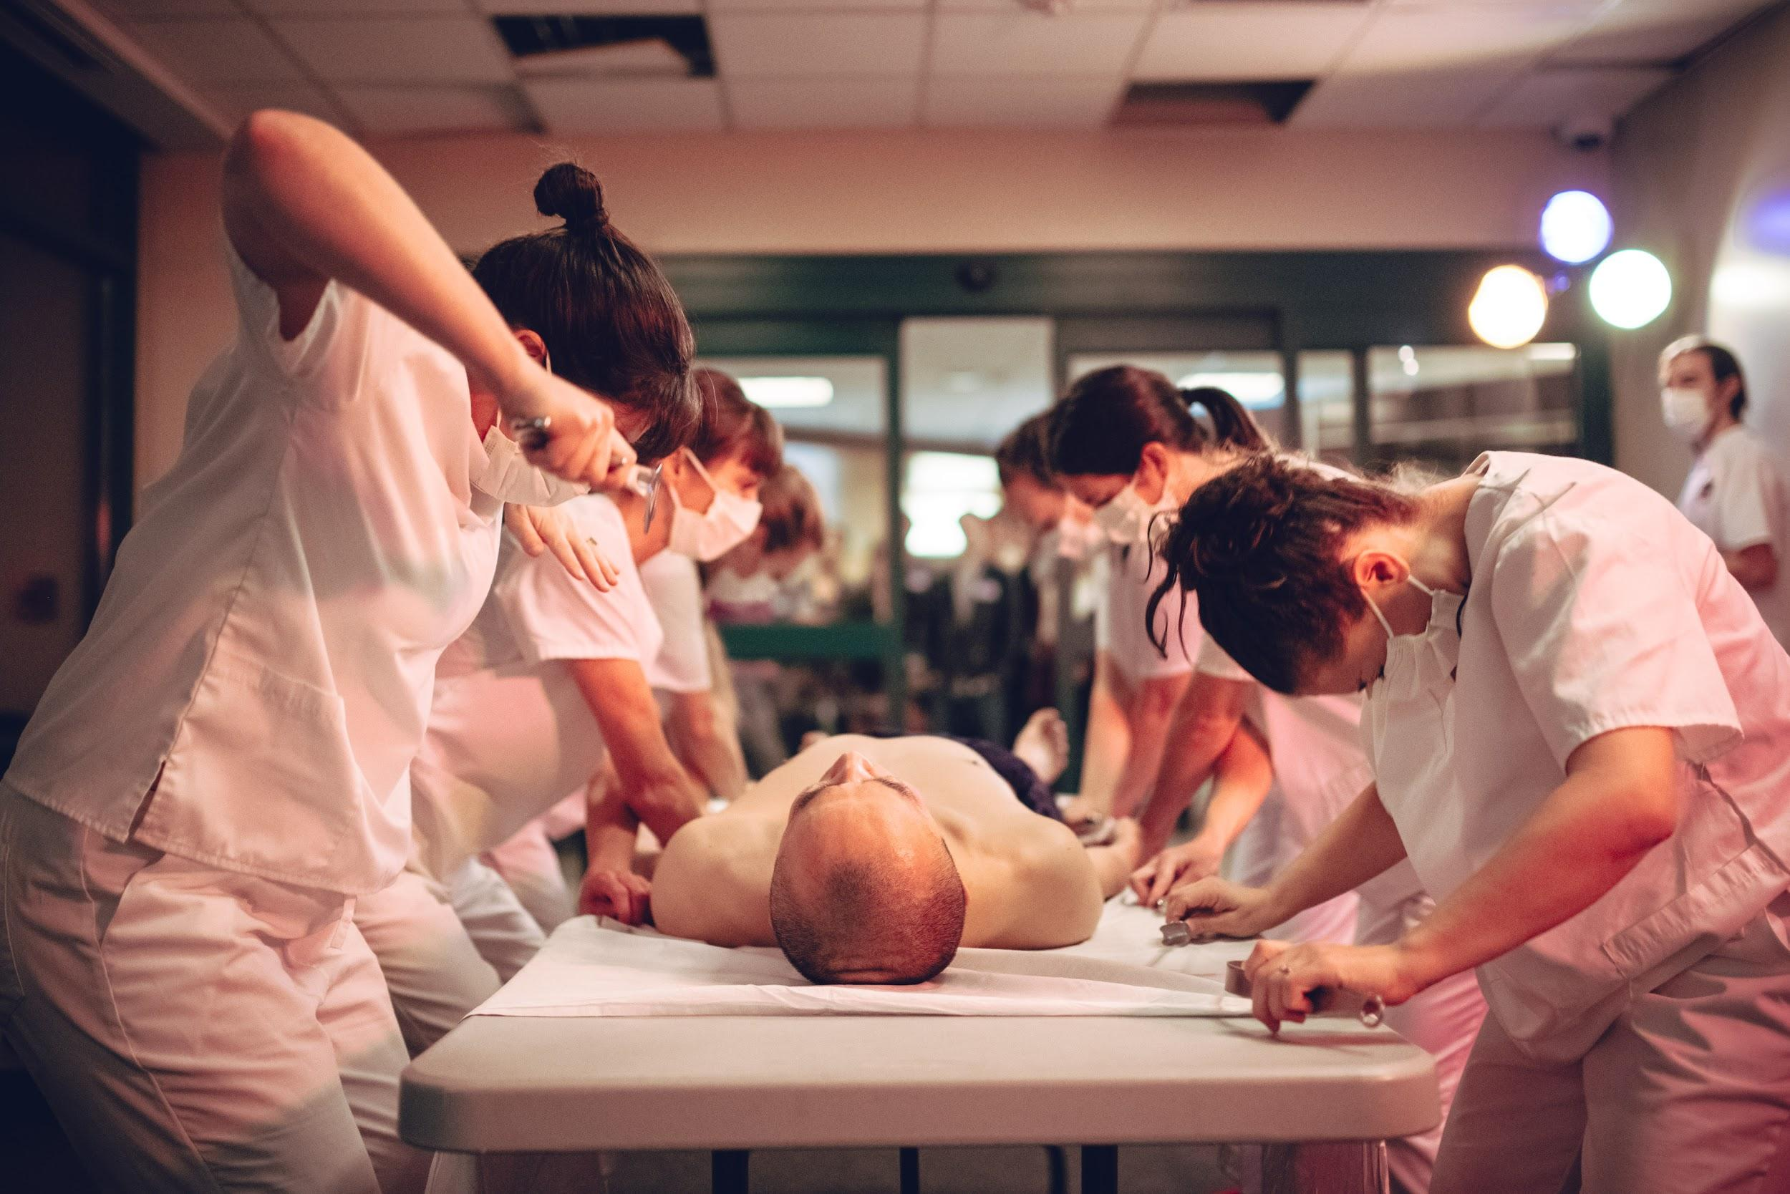
Nurse Tara Rynders and dancers performing in First, Do No Harm, an immersive theater performance that raises awareness of compassion fatigue and nursing burnout that took place in Rose Medical Center, an active hospital, and sold out 10 shows to the general public. Photo by DW Burnett
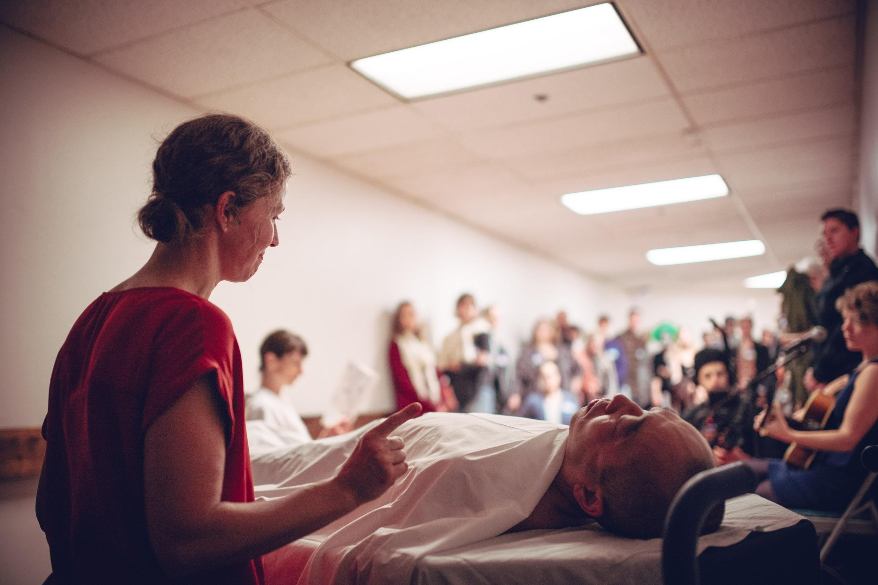
Performers Kristine Whittle and J.A. performing in First, Do No Harm, an immersive theater performance that raises awareness of compassion fatigue and nursing burnout that took place in Rose Medical Center, an active hospital, and sold out 10 shows to the general public. Photo by DW Burnett

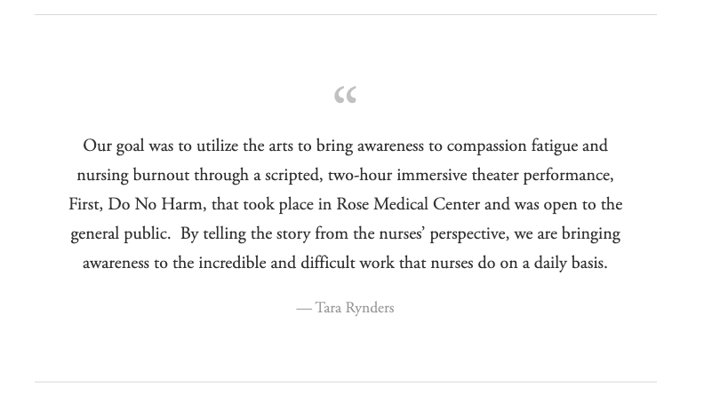
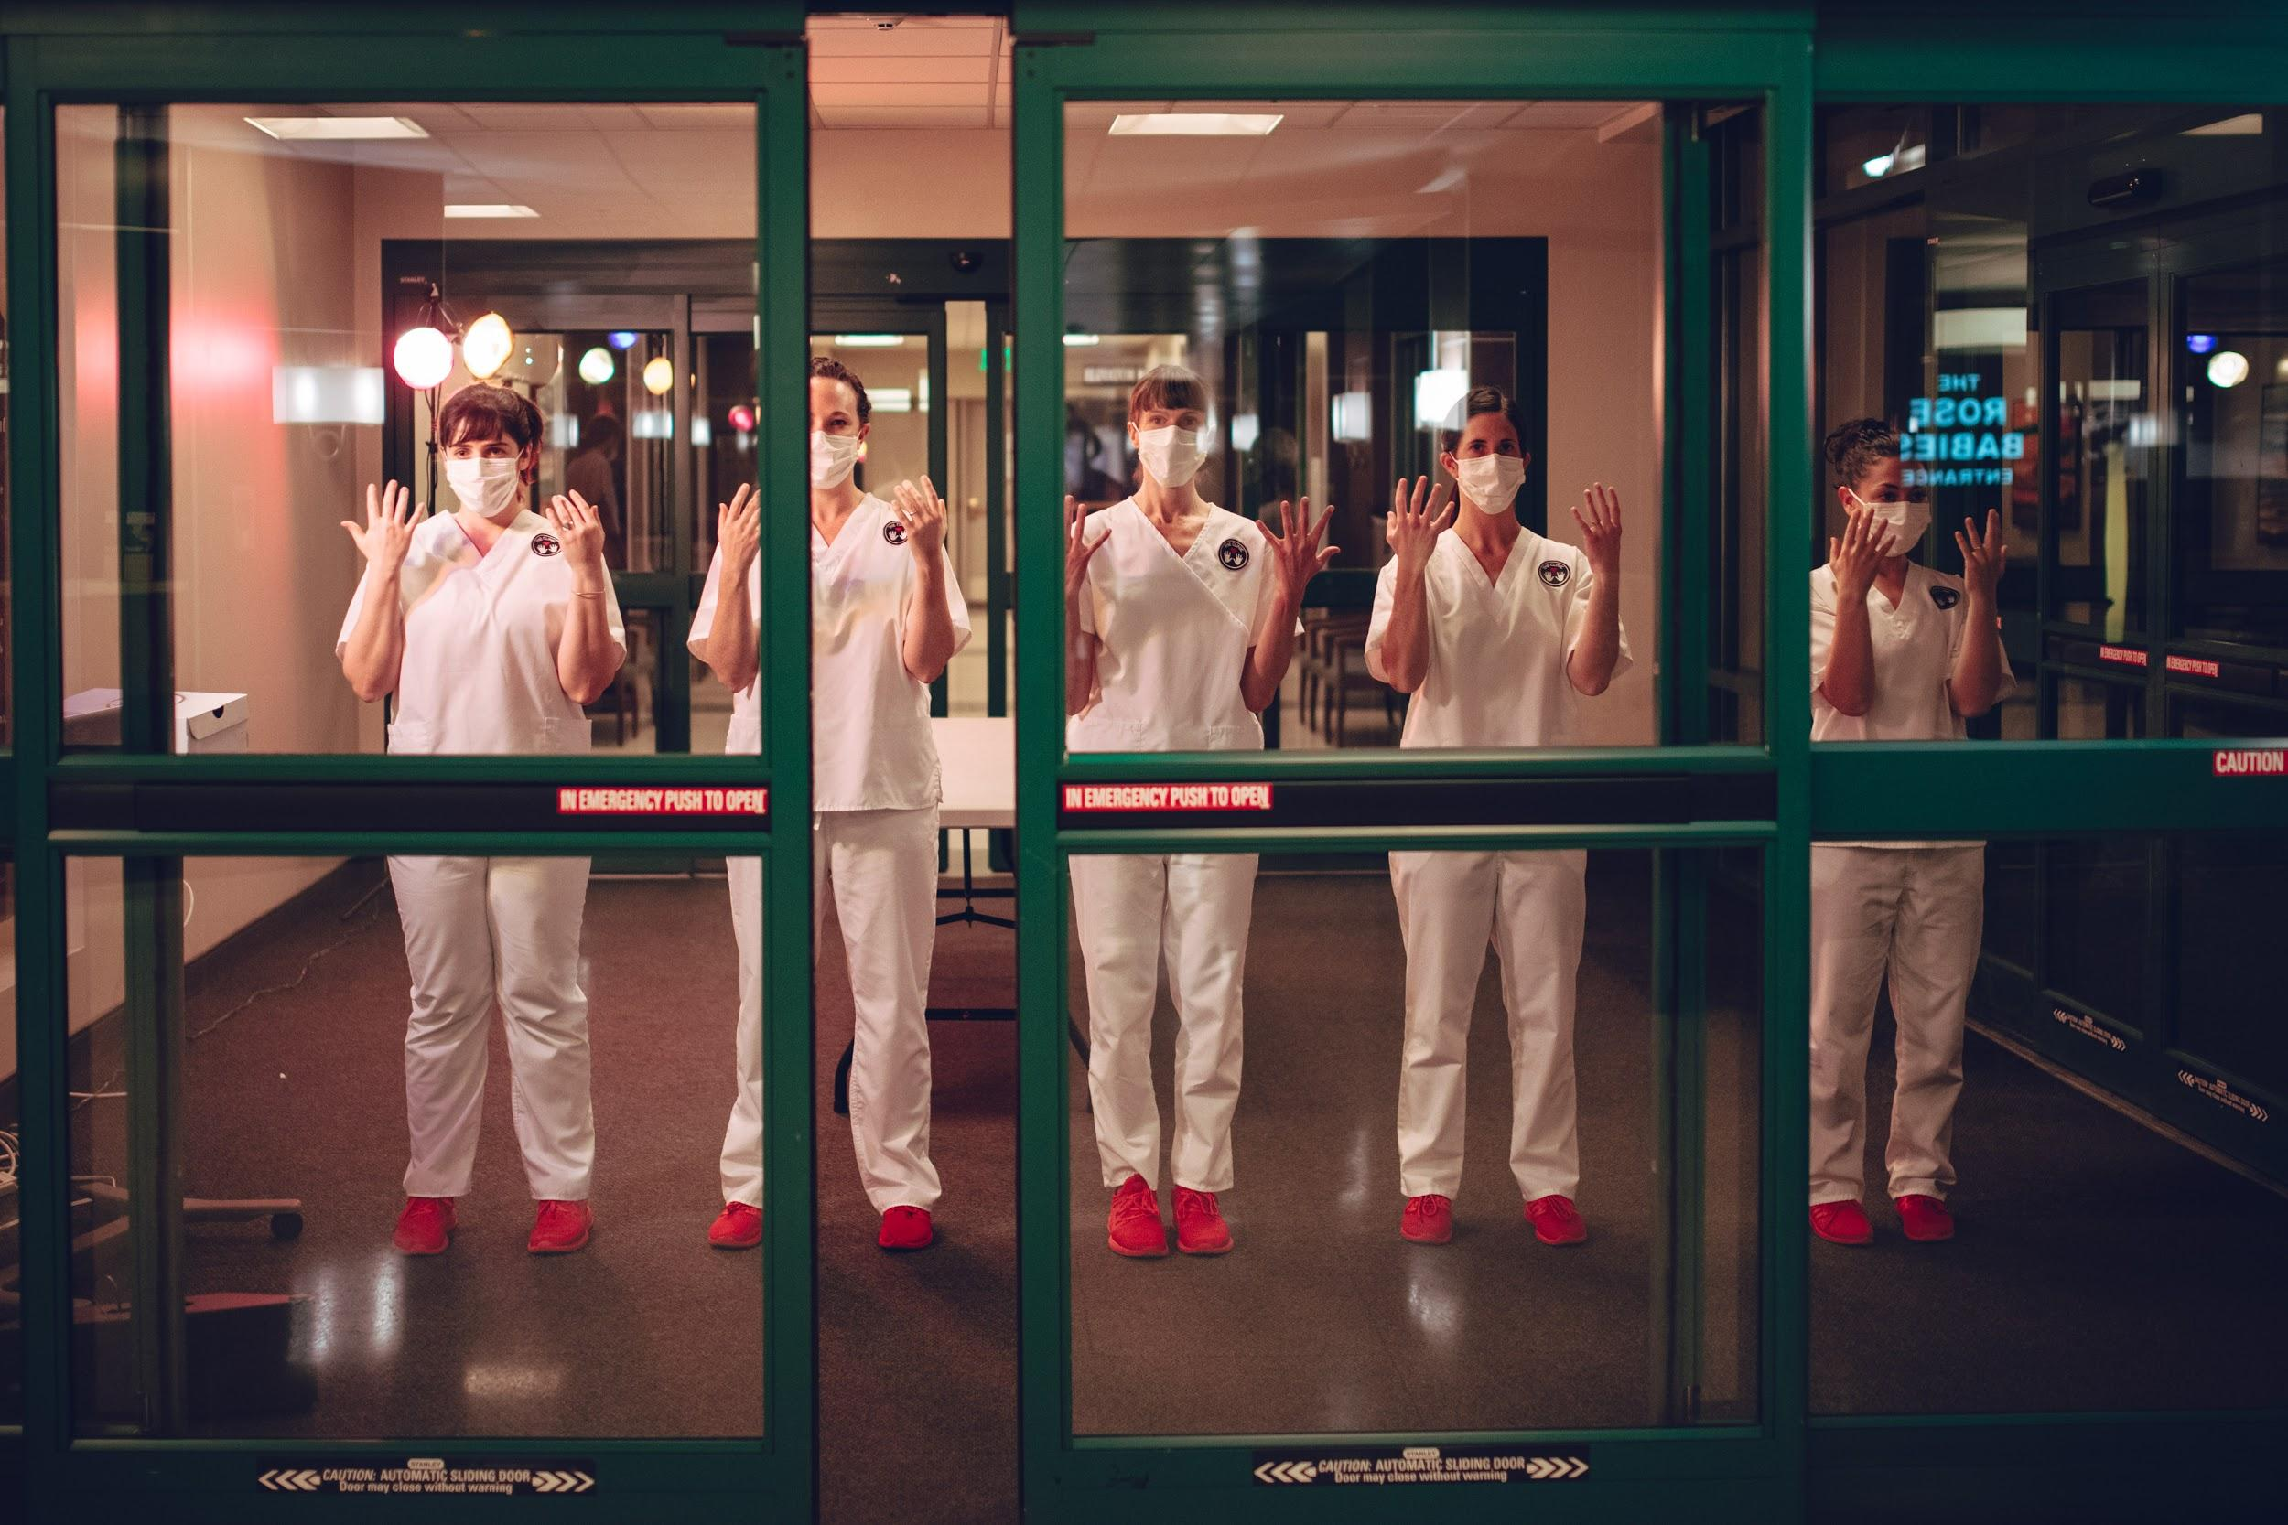
Nurse Tara Rynders and dancers performing in First, Do No Harm, an immersive theater performance that raises awareness of compassion fatigue and nursing burnout that took place in Rose Medical Center, an active hospital, and sold out 10 shows to the general public. Photo by DW Burnett
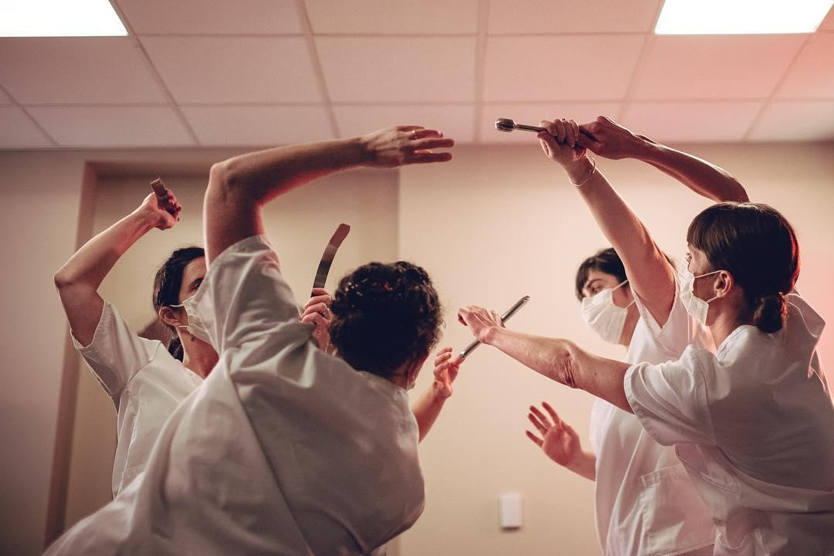
Nurse Tara Rynders and dancers performing in First, Do No Harm, an immersive theater performance that raises awareness of compassion fatigue and nursing burnout that took place in Rose Medical Center, an active hospital, and sold out 10 shows to the general public. Photo by DW Burnett
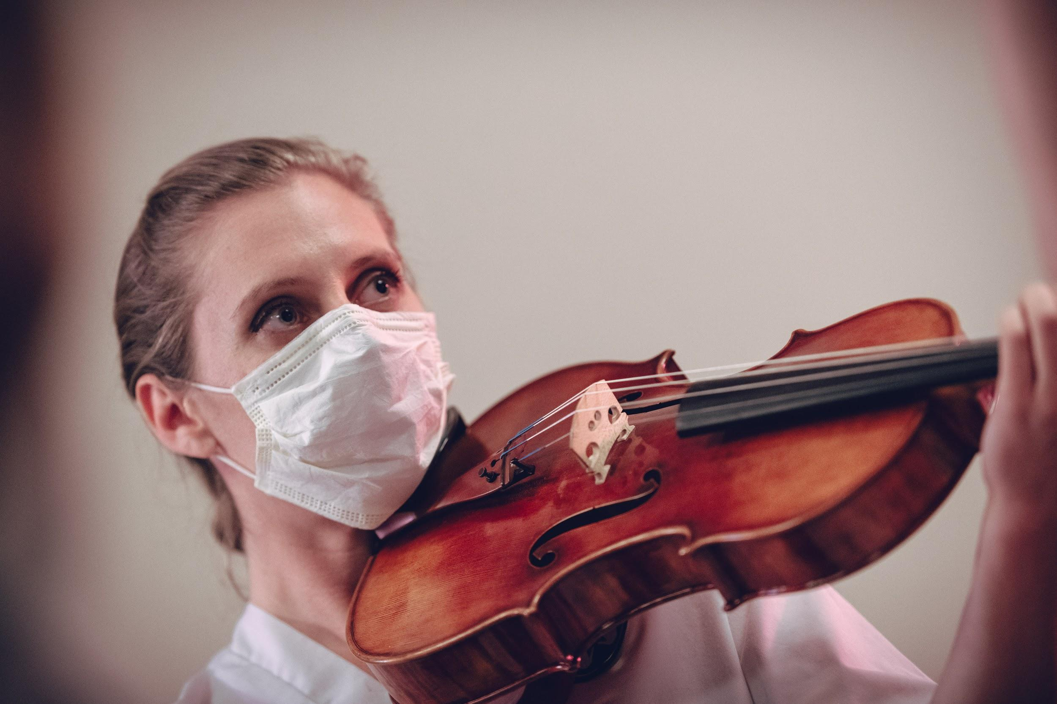
Performer Julie Rooney performing in First, Do No Harm, an immersive theater performance that raises awareness of compassion fatigue and nursing burnout that took place in Rose Medical Center, an active hospital, and sold out 10 shows to the general public. Photo by DW Burnett

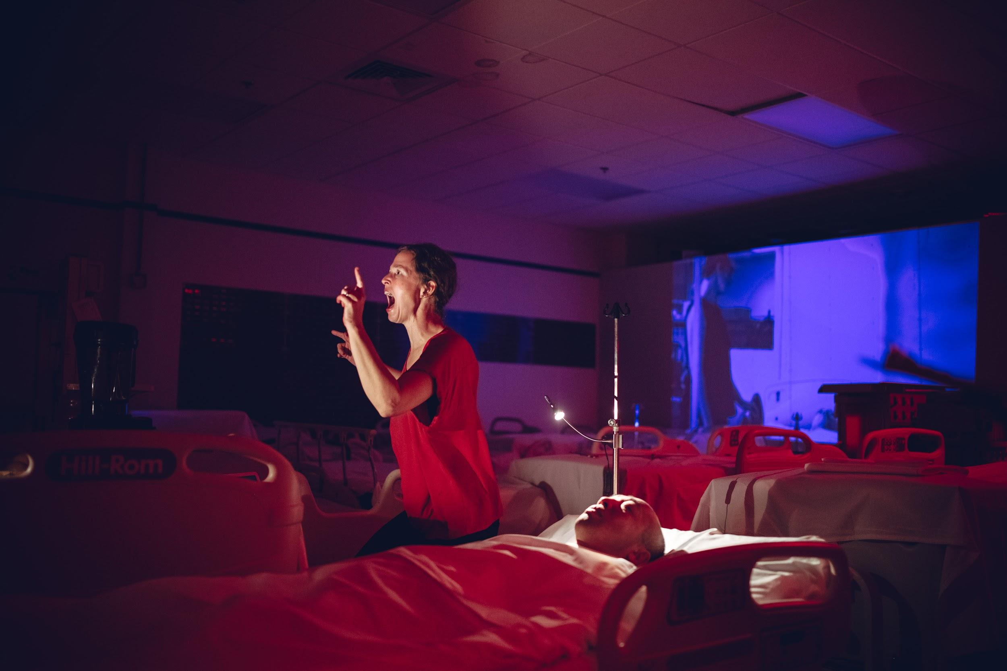
Performers Kristine Whittle and J.A. performing in First, Do No Harm, an immersive theater performance that raises awareness of compassion fatigue and nursing burnout that took place in Rose Medical Center, an active hospital, and sold out 10 shows to the general public. Photo by DW Burnett

Rynders recently (October 2019) facilitated a workshop for nurses with co-facilitator Clare Hammoor, using art, movement, and play-based theater to combat compassion fatigue and nursing burnout. (See short video here)
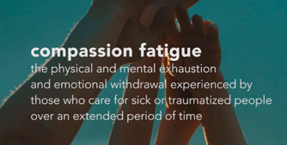
During this time she led an IRB approved research study to assess the outcomes of using art, movement, and play-based theater to help decrease burnout and secondary traumatic stress. (See positive results below)
During COVID-19 Rynders has created a virtual version of the resiliency workshops for nurses that will be offered during the Reimagine End of Life Festival in New York City this June. To offer support now, in this moment, Rynders has hired artists across the U.S., Europe and Lebanon to help create resiliency moments where healthcare workers can sign- up for fifteen minute increments to have a one on one moment with a “clinician”: visual artist, dancer, musician, somatic practitioner and more. During these one on one experiences the hope is that each person will see this time as a gift to feel seen and heard through this artistic experience where they feel supported during this time of COVID hardship. Each person will also receive an artifact in the mail that reflects the moment they spent with their prospective clinician. These moments come from Rynders earlier work as an immersive theater artist and director of You & Me, which toured nationally and internationally creating one on one intimate performances for one person at a time.
Most recently, in the midst of COVID -19, Rynders was asked by her CEO, Ryan Tobin of Rose Medical Center, to be taken off the floor as a bed-side nurse to round on nurses to help ensure their emotional, physical, and mental well-being were being cared for. This includes teaching movement and yoga classes, going to the nursing stations and listening to the fears, frustrations, and often rage of the current situation. Rynders leads each unit in daily meditations, stretches, and her most favorite, dance parties. During this time Rose Medical Center implemented “The Market”, which is a free food pantry in the hospital where staff can come and receive fresh produce and other food to support and care for their staff.
After a month of rounding, Rynder’s proposed a new role for herself as a nurse specialist on resiliency and wellness for the entire hospital staff. Rose Medical Center said yes and created a full-time position for her to transition into as a Nurse Specialist in resiliency and wellness focusing on leadership and development for all staff in her hospital. This education will be grounded in arts and innovative ways that interactively address grief recovery, self-care, fatigue, burnout, secondary traumatic stress, health-care disparities, caregiver bias, racism, and privilege.
Ultimately Rynders hopes to create more dialogue for nurses and other healthcare staff to feel seen, heard, and cared for. “Once our staff feels supported, feels seen, feels heard, feels cared for, only then will our patients feel this way as well. It is more evident now then ever that we are all inextricably connected and our bias, our fatigue, our burnout, our privilege hurt all of us and it is time to care for ourselves which includes focusing on how we can show up wholeheartedly without judgement, without bias so that our communities can thrive, so we can all reap the benefits and joy that come from authentically caring for our fellow human beings.”
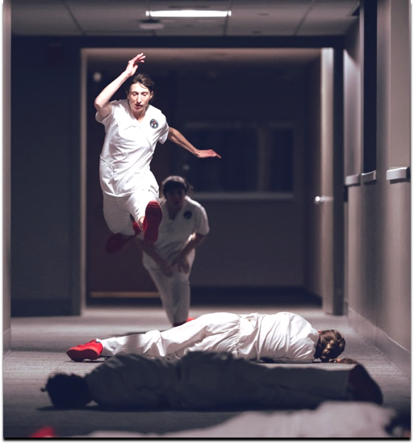
Nurse Tara Rynders performing in First, Do No Harm, an immersive theater performance that raises awareness of compassion fatigue and nursing burnout that took place in Rose Medical Center, an active hospital, and sold out 10 shows to the general public. Photo by DW Burnett
Past press and awards
A Blade of Grass Fellow 2019

NPR interview (Colorado Matters)
http://www.cpr.org/news/story/this-nurse-is-taking-audiences-behind-the-scenes-at-her-hospital-through-dance?fbclid=IwAR1Qxr9v8urNClfdqbve5tWrzRQPyRwUlWRFKZl1bSbvkiNeXuZWQeYKwdg
Arts in Society grantee 2020

Westword Interview

CBS press
https://denver.cbslocal.com/2018/10/18/rose-medical-center-nurse-dance-theater/?fbclid=IwAR2TAWY-U3CYin7veA7BT4Wkj2YrUf4hSalyh2FjtDs69RL8cNw8x3aT-Wk

RedLine Blog First, Do No Harm

Colorado Health Institute Interview

5280

Nightingale Award

Compassionate Care Award 2019 Rose Medical Center

Arts in Society Grantee 2017

Theclinicperformance.com
Tara Rynders
720-469-7134
theclinicperformance@gmail.com

